Helpful Links:
Desmos Calculator: https://www.desmos.com/calculator
https://www.desmos.com/scientific
https://www.desmos.com/fourfunction

Downloadable Calculator: https://www.meta-calculator.com/

Printable Customizable Graph Paper: https://www.math-aids.com/Graph_Paper/
https://incompetech.com/graphpaper/plain/

STAAR Mathematics Resources (all grade levels): https://tea.texas.gov/student-assessment/testing/staar/staar-mathematics-resources

Multiplication Chart: https://www.mathsisfun.com/tables.html

Mathway (use menu to change to different math levels): https://www.mathway.com/PreAlgebra

Everfi (if Clever isn’t working. Student will have to sign in with school email):
https://platform.everfi.net/dashboard

HISD Clever: Type “HISD Clever” in any search engine or click the link below.
https://clever.com/oauth/authorize?channel=clever&client_id=4c63c1cf623dce82caac&confirmed=true&district_id=53ea7128ba7f53280d000032&redirect_uri=https%3A%2F%2Fclever.com%2Fin%2Fauth_callback&response_type=code&state=1cb02af8417c736f27c60cf3472b582b0a048d97298d9d1824eead03d0e7b693

Helpful Clever Resources (these are images to help you identify them easily):
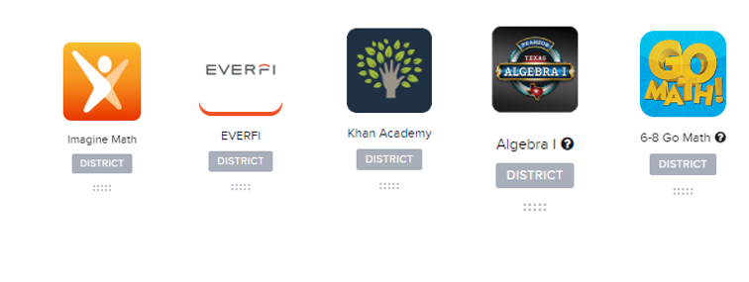

Printable Documents:
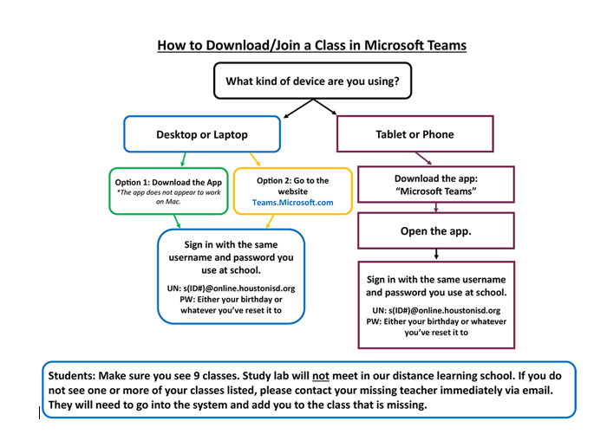

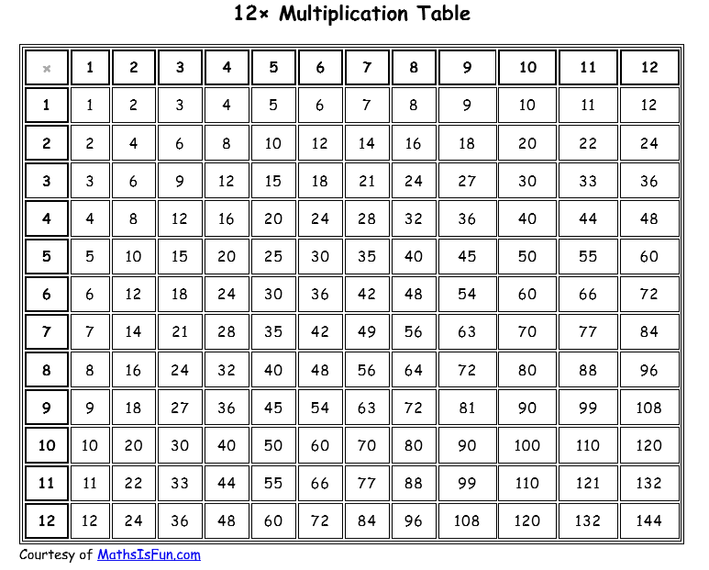

RULER NOT TO SCALE- Use link on first page to access document on TEA website.
RULER NOT TO SCALE- Use link on first page to access document on TEA website.

RULER NOT TO SCALE- Use link on first page to access document on TEA website.

